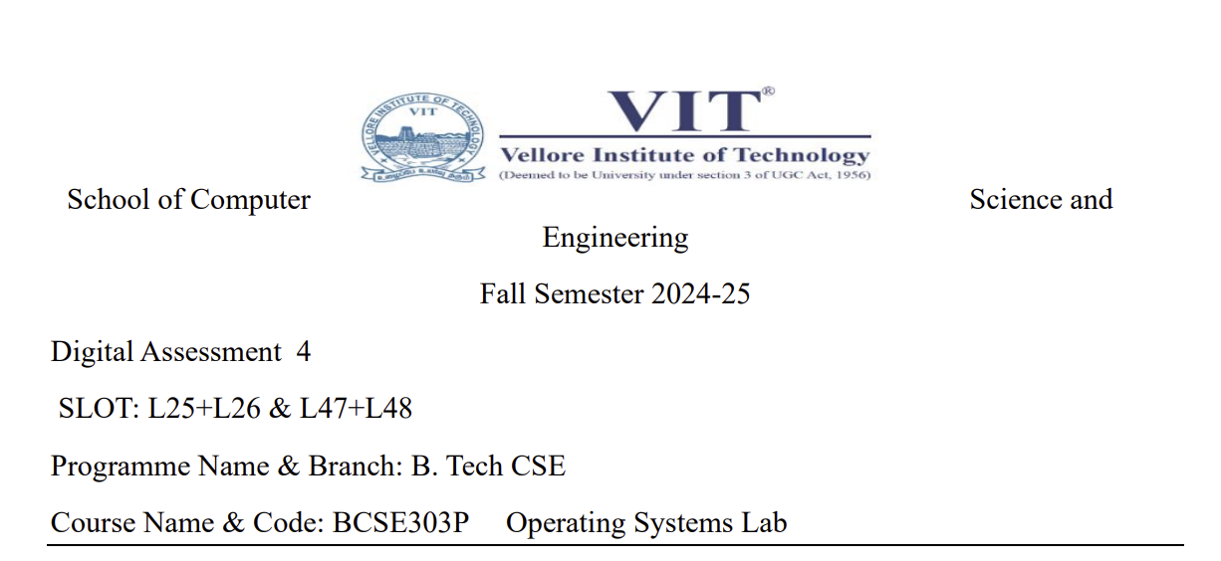

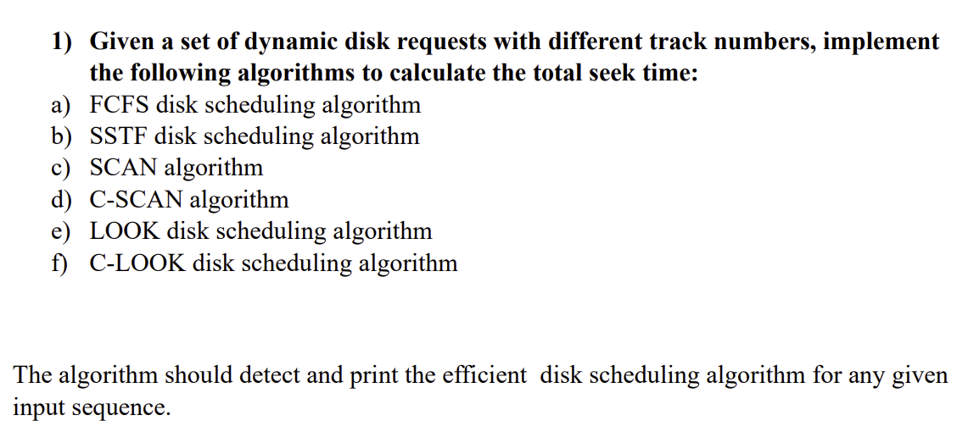

**CODE:**

#include <iostream>

#include <vector>

#include <algorithm>

#include <cmath>

using namespace std;

int FCFS(const vector<int>& *fcfs_requests*, int *fcfs_head_position*) {

    int fcfs_seek_time = 0;

    for (int fcfs_request : *fcfs_requests*) {

        fcfs_seek_time += abs(fcfs_request - *fcfs_head_position*);

*fcfs_head_position* = fcfs_request;

    }

    return fcfs_seek_time;

}

int SSTF(vector<int> *sstf_requests*, int *sstf_head_position*) {

    int sstf_seek_time = 0;

    while (!*sstf_requests*.empty()) {

        auto closest_request = min_element(*sstf_requests*.begin(), *sstf_requests*.end(),

                                           [*sstf_head_position*](int *a*, int *b*) {

                                               return abs(*a* - *sstf_head_position*) < abs(*b* - *sstf_head_position*);

                                           });

        sstf_seek_time += abs(*closest_request - *sstf_head_position*);

*sstf_head_position* = *closest_request;

*sstf_requests*.erase(closest_request);

    }

    return sstf_seek_time;

}

int SCAN(vector<int> *scan_requests*, int *scan_head_position*, int *scan_disk_size*) {

    int scan_seek_time = 0;

*scan_requests*.push_back(0);

*scan_requests*.push_back(*scan_disk_size* - 1);

    sort(*scan_requests*.begin(), *scan_requests*.end());

    auto scan_position = lower_bound(*scan_requests*.begin(), *scan_requests*.end(), *scan_head_position*);

    for (auto it = scan_position; it != *scan_requests*.end(); ++it) {

        scan_seek_time += abs(*it - *scan_head_position*);

*scan_head_position* = *it;

    }

    for (auto it = scan_position - 1; it >= *scan_requests*.begin(); --it) {

        scan_seek_time += abs(*it - *scan_head_position*);

*scan_head_position* = *it;

    }

    return scan_seek_time;

}

int C_SCAN(vector<int> *cscan_requests*, int *cscan_head_position*, int *cscan_disk_size*) {

    int cscan_seek_time = 0;

*cscan_requests*.push_back(0);

*cscan_requests*.push_back(*cscan_disk_size* - 1);

    sort(*cscan_requests*.begin(), *cscan_requests*.end());

    auto cscan_position = lower_bound(*cscan_requests*.begin(), *cscan_requests*.end(), *cscan_head_position*);

    for (auto it = cscan_position; it != *cscan_requests*.end(); ++it) {

        cscan_seek_time += abs(*it - *cscan_head_position*);

*cscan_head_position* = *it;

    }

    cscan_seek_time += abs(*cscan_disk_size* - 1 - *cscan_head_position*);

*cscan_head_position* = 0;

    for (auto it = *cscan_requests*.begin(); it < cscan_position; ++it) {

        cscan_seek_time += abs(*it - *cscan_head_position*);

*cscan_head_position* = *it;

    }

    return cscan_seek_time;

}

int LOOK(vector<int> *look_requests*, int *look_head_position*) {

    int look_seek_time = 0;

    sort(*look_requests*.begin(), *look_requests*.end());

    auto look_position = lower_bound(*look_requests*.begin(), *look_requests*.end(), *look_head_position*);

    for (auto it = look_position; it != *look_requests*.end(); ++it) {

        look_seek_time += abs(*it - *look_head_position*);

*look_head_position* = *it;

    }

    for (auto it = look_position - 1; it >= *look_requests*.begin(); --it) {

        look_seek_time += abs(*it - *look_head_position*);

*look_head_position* = *it;

    }

    return look_seek_time;

}

int C_LOOK(vector<int> *clook_requests*, int *clook_head_position*) {

    int clook_seek_time = 0;

    sort(*clook_requests*.begin(), *clook_requests*.end());

    auto clook_position = lower_bound(*clook_requests*.begin(), *clook_requests*.end(), *clook_head_position*);

    for (auto it = clook_position; it != *clook_requests*.end(); ++it) {

        clook_seek_time += abs(*it - *clook_head_position*);

*clook_head_position* = *it;

    }

    for (auto it = *clook_requests*.begin(); it < clook_position; ++it) {

        clook_seek_time += abs(*it - *clook_head_position*);

*clook_head_position* = *it;

    }

    return clook_seek_time;

}

int main() {

    int total_requests, initial_head_position, disk_capacity;

    cout << "Enter the number of requests: ";

    cin >> total_requests;

    vector<int> input_requests(total_requests);

    cout << "Enter the requests: ";

    for (int i = 0; i < total_requests; ++i) cin >> input_requests[i];

    cout << "Enter the initial head position: ";

    cin >> initial_head_position;

    cout << "Enter the disk size: ";

    cin >> disk_capacity;

    int fcfs_seek = FCFS(input_requests, initial_head_position);

    int sstf_seek = SSTF(input_requests, initial_head_position);

    int scan_seek = SCAN(input_requests, initial_head_position, disk_capacity);

    int c_scan_seek = C_SCAN(input_requests, initial_head_position, disk_capacity);

    int look_seek = LOOK(input_requests, initial_head_position);

    int c_look_seek = C_LOOK(input_requests, initial_head_position);

    cout << "FCFS Seek Time: " << fcfs_seek << endl;

    cout << "SSTF Seek Time: " << sstf_seek << endl;

    cout << "SCAN Seek Time: " << scan_seek << endl;

    cout << "C-SCAN Seek Time: " << c_scan_seek << endl;

    cout << "LOOK Seek Time: " << look_seek << endl;

    cout << "C-LOOK Seek Time: " << c_look_seek << endl;

    int min_seek_time = min({fcfs_seek, sstf_seek, scan_seek, c_scan_seek, look_seek, c_look_seek});

    cout << "Most efficient algorithm: ";

    if (min_seek_time == fcfs_seek) cout << "FCFS";

    else if (min_seek_time == sstf_seek) cout << "SSTF";

    else if (min_seek_time == scan_seek) cout << "SCAN";

    else if (min_seek_time == c_scan_seek) cout << "C-SCAN";

    else if (min_seek_time == look_seek) cout << "LOOK";

    else if (min_seek_time == c_look_seek) cout << "C-LOOK";

    cout << " with Seek Time: " << min_seek_time << endl;

    return 0;

}

**OUTPUT:**

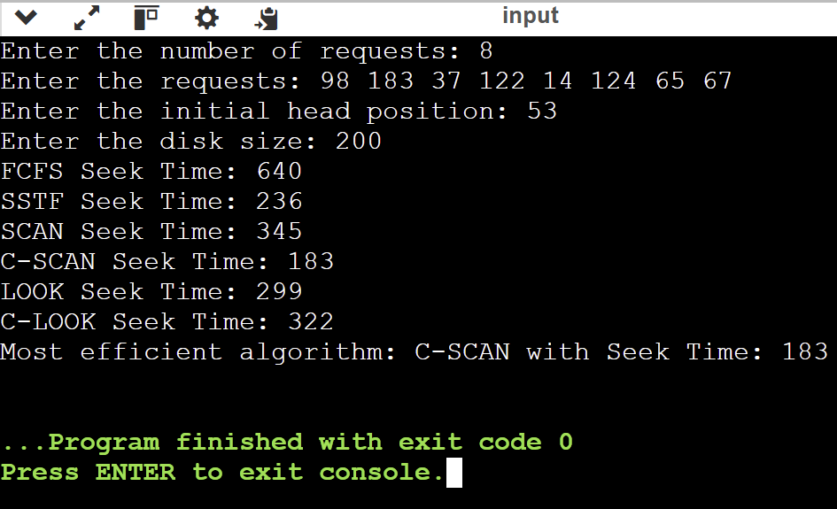

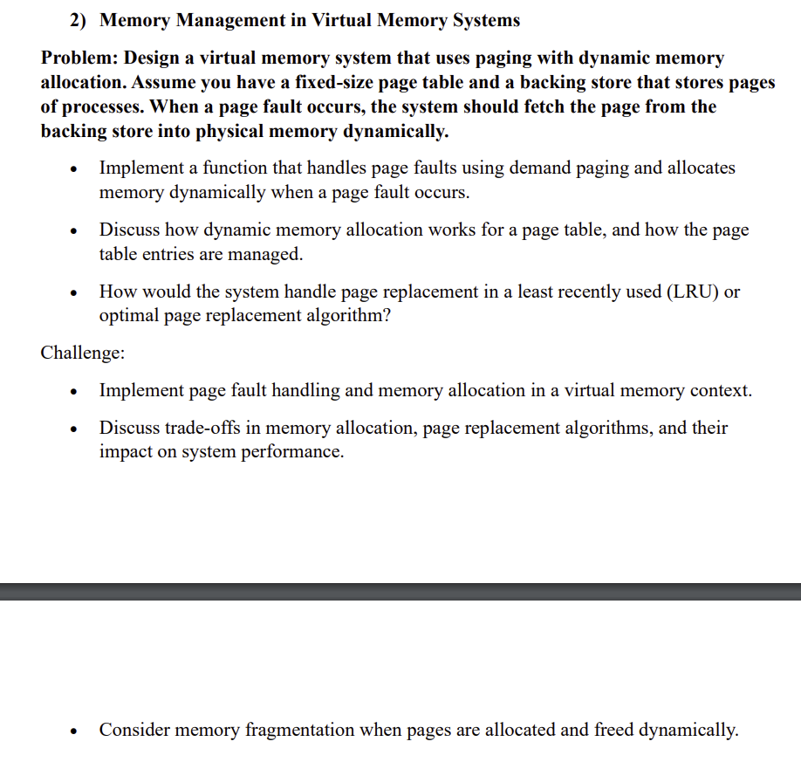

**CODE:**

#include <iostream>

#include <unordered_map>

#include <list>

#include <vector>

using namespace std;

class MemoryManager {

    int maxPageTableSize, frameSize, memoryCapacity;

    vector<int> secondaryStorage;

    unordered_map<int, int> pageDirectory;

    list<int> recentlyUsedPages;

    unordered_map<int, list<int>::iterator> pageLookup;

    vector<int> mainMemory;

public:

    MemoryManager(int *maxTableSize*, int *frameBytes*, int *totalMemory*, const *vector*<int>& *storage*)

        : maxPageTableSize(maxTableSize), frameSize(frameBytes), memoryCapacity(totalMemory), secondaryStorage(storage) {

        mainMemory.resize(memoryCapacity / frameSize, -1);

    }

    void loadPage(int *virtualAddress*) {

        int targetPage = virtualAddress / frameSize;

        if (pageDirectory.find(targetPage) == pageDirectory.end()) {

            cout << "Page fault for page: " << targetPage << endl;

            processPageFault(targetPage);

        } else {

            cout << "Page " << targetPage << " found in frame: " << pageDirectory[targetPage] << endl;

            refreshLRU(targetPage);

        }

    }

    void processPageFault(int *page*) {

        int freeFrame = findFreeMemoryFrame();

        if (freeFrame == -1) {

            freeFrame = performPageReplacement();

        }

        pageDirectory[page] = freeFrame;

        mainMemory[freeFrame] = secondaryStorage[page];

        cout << "Page " << page << " loaded into frame " << freeFrame << endl;

        refreshLRU(page);

    }

    int findFreeMemoryFrame() {

        for (int i = 0; i < mainMemory.size(); i++) {

            if (mainMemory[i] == -1) return i;

        }

        return -1;

    }

    int performPageReplacement() {

        int leastUsedPage = recentlyUsedPages.back();

        recentlyUsedPages.pop_back();

        int replacedFrame = pageDirectory[leastUsedPage];

        pageDirectory.erase(leastUsedPage);

        cout << "Page " << leastUsedPage << " removed from frame " << replacedFrame << endl;

        return replacedFrame;

    }

    void refreshLRU(int *page*) {

        if (pageLookup.find(page) != pageLookup.end()) {

            recentlyUsedPages.erase(pageLookup[page]);

        }

        recentlyUsedPages.push_front(page);

        pageLookup[page] = recentlyUsedPages.begin();

    }

};

int main() {

    int tableLimit, frameBytes, memorySize;

    cout << "Enter page table capacity: ";

    cin >> tableLimit;

    cout << "Enter size of each page frame: ";

    cin >> frameBytes;

    cout << "Enter total memory size: ";

    cin >> memorySize;

    int secondaryStorageSize;

    cout << "Enter size of secondary storage (backing store): ";

    cin >> secondaryStorageSize;

    vector<int> secondaryStorage(secondaryStorageSize);

    cout << "Enter data for each page in the secondary storage: ";

    for (int i = 0; i < secondaryStorageSize; i++) {

        cin >> secondaryStorage[i];

    }

    MemoryManager memSystem(tableLimit, frameBytes, memorySize, secondaryStorage);

    int addressCount;

    cout << "Enter number of virtual addresses to access: ";

    cin >> addressCount;

    cout << "Enter the virtual addresses: ";

    for (int i = 0; i < addressCount; i++) {

        int address;

        cin >> address;

        memSystem.loadPage(address);

    }

    return 0;

}

**OUTPUT:**

